Dance for Parkinson’s offers people with Parkinson’s, their carers and family members a high quality artistic and engaging dance activity within a professional arts environment. Weekly dance classes provide a creative and artistic opportunity for participants within a supportive and social environment, in addition to providing positive benefit to physical and mental health and wellbeing.
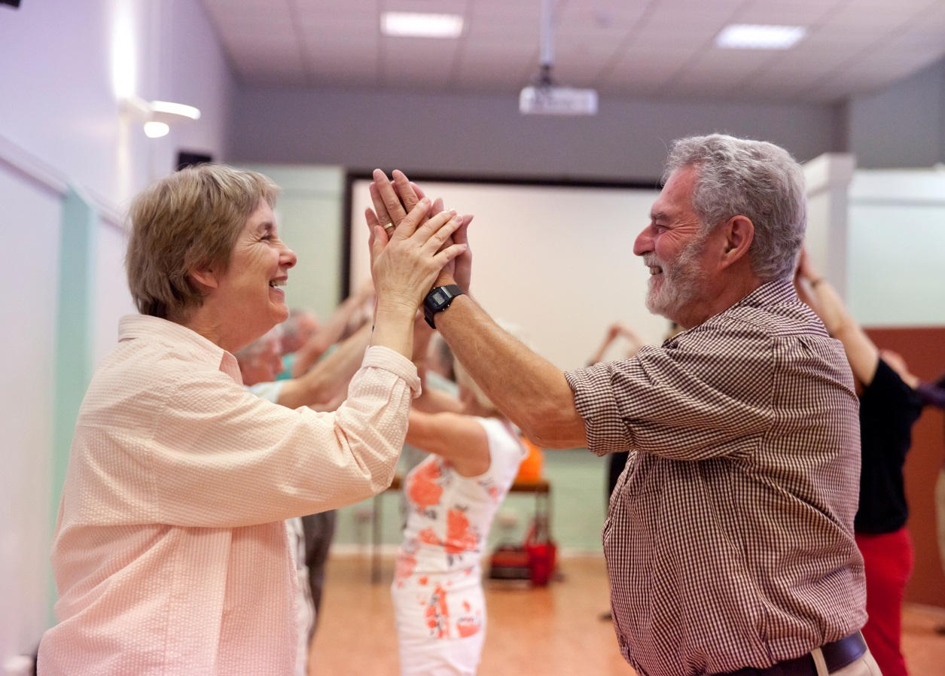
It is a partnership programme between English National Ballet and Oxford City Council, which was set up in Oxford in 2013. Alongside weekly classes, participants also attend trips to see English National Ballet's performances. Classes run weekly on a Monday, between 1.00-2.15pm (followed by refreshments / social time) at the Wesley Memorial Hall, New Inn Hall Street. With 42 participants on the register, we average approx. 30-35 people per session and currently have a waiting list for the classes.
We have recently been gathering feedback from the participants about their experience of the classes and some of the responses included:
“Dance for Parkinson’s is more to me than an hour or so each week. It has changed my life. Two years ago the BBC decided to make a little 10 minute film about the Oxford Dance for Parkinson’s classes. They asked me to present it because although I have never presented anything in my life I am a comedy writer and used to work for the BBC. A few weeks later it turned into a half hour documentary called "Parkinson’s: The funny Side” and the programme has had the most amazing response. In particular, people tell me that they no longer fear Parkinson’s. They understand it better but they are no longer scared of it.
I learned a lot making the programme. In particular I am now convinced that music, dance and laughter have the power to help us combat Parkinson’s. I don’t know how, but they raise our spirits, lift our hearts and light up bits of our brains in ways that make us FEEL better.
I am now doing all I can to convey this message. I give talks, I’ve started doing standup and I’m writing a romcom comedy drama about two people with Parkinson’s who fall in love at ballet classes.
So thank you for sending my life in a wholly unexpected and wonderful fulfilling direction”. (Paul Mayhew-Archer)

Parkinson’s: The Funny Side is permanently available on BBC iplayer under “Inside Out South”. Paul has made a little follow up which also features Ballet for Parkinson’s and his first attempt at standup at London’s Comedy Store. This is available on iplayer under "Inside Out South" until the end of November 2017

“Highlight of my week, for four years. It may get hard but it hasnʼt put me off. The atmosphere is special. It’s unique in many ways”. (Wendy)
“I always like the light and warm atmosphere. I always feel wonderful, full of energy and full of life after each session!” (Robin)

“They manage to conjure up a beautiful atmosphere filled with music, movement and laughter, that allows us to forget, at least for an hour or so, our daily cares. They are all angels and we love them to bits!” (Anonymous)

The classes are currently supported by Parkinson’s UK (Oxford branch)

